

#### Mercy Health-St. Vincent Medical Center and Nationwide Children’s Hospital

Toledo Ohio

# Student Handbook

Darcy Browne, MA. Ed.

Academic Student Program Administrator 2222 Cherry Street, MOB2 Suite 1300

Toledo Ohio 43608 O:419-251-2895 F:419-251-7717

*Our Mission is to extend the compassionate ministry of Jesus by improving the health and well-being of our communities and bring good help to those in need, especially people who are poor, dying and underserved.*

Welcome!

We are glad you are here! At Mercy Health-St. Vincent and Nationwide Children’s Hospital

-Toledo (NCH-T)we strive to provide our students, whether here as a core member or as a visiting student, with a quality and comprehensive clinical education experience.

Each member of our faculty, be it a clerkship director, resident, or faculty staff member in GME, are committed to helping you grow in your chosen selfless profession. We understand that you have made many sacrifices to be here with us and on behalf of GME we thank you for that!

This handbook is designed to be a comprehensive guide to answer your possible questions prior to rotating with us but also while rotating with us!

Once again, welcome to St. Vincent and Nationwide Children’s Hospital-Toledo!

Dr. Randall Schlievert, DIO Dr. Heather Meade, DME

Mercy Health-St. Vincent Medical Center Nationwide Childrens Hospital-Toledo

**OUR VISION**

**Inspired by God’s hope for the world, we will be a ministry where associates want to work, clinicians want to practice, people seek wellness, and communities thrive.**

**OUR VALUES**

**Human Dignity**

We commit to upholding the sacredness of life and being respectful and inclusive of everyone.

**Integrity**

We commit to acting ethically and modeling right relationships in all of our individual and organizational encounters.

**Compassion**

We commit to accompanying those we serve with mercy and tenderness, recognizing that “being with” is as important as “doing for.”

**Stewardship**

We commit to promoting the responsible use of all human and financial resources, including Earth itself.

**Service**

We commit to providing the highest quality in every dimension of our ministry.

### Scheduling Process Core:

Core students for OUHCOM, Mercy PA and SGU

The scheduling for your core rotations will be determined, with the help of your respective schools, at the beginning of the program year. Evaluation completion for core rotations is also done within the guidelines of your respective schools. This could be online, on paper or other processes deemed acceptable by your university.

You will be notified at the beginning of each month of your core rotation and at that time you will receive your schedule and reporting instructions. Each rotation has their own orientation and goals and objectives so it is important to read the reporting instructions that will be provided to you.

Any scheduling change of a core rotation must go through your coordinator for me to confirm if the change is available or not. Please hold to your core rotations as scheduled unless there is an emergent need to change.

#### Scheduling Process Electives:

As a PA, a visiting 4th year student or returning 4th year student it is important to schedule your electives as early as possible and with some finality in the choices. Obviously during certain times of the year, particularly Fall, the electives can fill up quickly, and/ or the rotations have limitations on the number of students that can rotate at a given time.

We want to make sure that your learning experience is comprehensive, informative and allows you the educational opportunities to further your profession. It is important that you understand that if you change your electives throughout the year, you may lose that elective due to other students signing up for the date earlier than you.

***Beginning August 4, 2025, elective rotations will only begin on every other Monday. UTMC, OHCOM and Mercy College will start rotations on dates scheduled with their coordinator.***

This change allows our rotations to provide you with optimal orientation experiences and rotation expectations with the assigned resident, attending or faculty member.

Please, keep this in mind as you are scheduling. This schedule change will also ensure that you receive a two- or four-week rotation consecutively for an optimal experience.

To help you begin the scheduling process, review the bulleted points below:

* Make sure that you understand the criteria from the university for types and numbers of weeks for a rotation.
* You have completed the student information that is necessary to confirm your rotation and given the signed forms to me/ student coordinator at Mercy St. Vincent’s. (*Appendix)*
* Have specific dates in mind, along with the name of the rotation so that time and efficacy when scheduling can be managed.
* Communicate and read emails sent regarding the rotations during the confirmation process. Do not assume you are confirmed!
* Know your institutions expectations for evaluations and handle those evaluations for each elective rotation.
* Schedule in advance, rotations do fill up quickly.
* Electives do have student limitations regarding number of learners. Some only have one learner including residents so have a plan B if your elective is full.
* Schedule with me once you have solidified your choices.
* Elective rotations canceled by you, may not be available again. Don’t cancel an elective until you are sure you have something to replace it.
* New elective choices must be submitted to the GME office **no later than 6 weeks** prior to the rotation. I need to have ample time to contact the rotations for scheduling and orientations.
* Please notify me upon scheduling if you are seeking a rotation as an audition, Sub I, or elective. This information is needed to properly onboard you and communicate your schedule.

I know that scheduling a year out and working with many institutions must be challenging. I am here to help you in any way possible and will understand and work with any emergencies or missed rotations that may arise. Please also reach out to your advisor at your university or rotation coordinator on site for help or concerns that arise.

**Medical Student Electives**

The following are electives available to choose from. Please know that choosing doesn’t mean we can confirm the rotation at the time and dates requested. We will work with you the best we can to give you what you want.

|  |  |  |
| --- | --- | --- |
| **St. Vincent Mercy Rotations** | **St. Vincent Mercy Rotations** | **Nationwide Childrens -Toledo** |
| Internal Medicine- Elect/ SUB I | General Surgery- Elect/ SUB I Electives are trauma, vascular, plastic, SICU, general, pediatrics, Uro/Gyn. And orthopedic | Pediatric Elective and SUB I  4th year students only |
| Cardiology | Family Medicine- Elect. / SUB I | PICU |
| Nephrology | Anesthesia (2 weeks) | NICU |
| Pulmonology | Neurology | Pediatric Hemo/Oncology |
| Physical Medicine &Rehab. | Pathology (2 weeks) | Pediatric Pulmonary |
| GI | OB/GYN | Pediatric Neurology |
| Emergency Medicine  Emergency Medicine- Ultrasound (2 weeks) | Palliative Care (2 weeks) Hemo/Oncology (2weeks) | Pediatric Nephrology Pediatric GI Pediatric Cardiology Pediatric Urology |

**Can be 3 weeks/ 6 weeks for Electives. Highlighted are 3 weeks only.**

|  |  |  |  |  |  |  |  |  |  |  |  |
| --- | --- | --- | --- | --- | --- | --- | --- | --- | --- | --- | --- |
| **St. Vincent Mercy-Toledo** | | |  | **Nationwide Childrens Hospital Toledo** | | | | | | |  |
| Emergency Medicine-CORE | | |  | Pediatric Oncology/ Hematology | | | | |  | | |
| Gastroenterology | | |  | Pediatric - Nephrology | | |  | | | | |
| Orthopedic Surgery | | |  | Pediatric - Neurology | | |  | | | | |
| Obstetrics/Gynecology-Women’s Health-CORE | | |  | Pediatric - NICU |  | | | | | | |
|  | Hematology/Oncology |  |  | Pediatric - PICU |  | | | | | | |
| Infectious Disease | | |  | Pediatric - Pulmonary | | |  | | | | |
| Internal Medicine-CORE | | |  | Pediatric - Urology | |  | | | | | |
| Nephrology | | |  | Physical Medicine & Rehabilitation | | | | | |  | |
| Pulmonary | | |  | Pediatric - Cardiology | | |  | | | | |
| Neurology | | | Pediatrics General-CORE-includes a clinic week | | | | | | | | |
| Surgery - Plastics | | | Pediatrics ENT | | | | | | | | |
| Surgery – SICU/ Trauma | | |  | Pediatric - Gastroenterology | | | |  | | | |
| Surgery –CORE | | |  | | | | | | | | |
| Surgery - Vascular | | |  | | | | | | | | |
| Cardiology | | |  | | | | | | | | |

#### General Information

*Provided as an overall guide to rotating at St. Vincent and NCH-T. . Please refer to your institutions handbook for questions that may not be addressed in this section.*

**Absences/ Days Off**

All absences regardless of the reason need to be shared with Darcy Browne and with your rotation attending or resident. If it is an approved day for an exam or for interviews, I will try to schedule and inform your rotation ahead of time. Students are expected to communicate with the rotation directly for scheduled absences. If it is an unexpected absence, please call Darcy Browne (419-346-9267) and the rotation; she will follow up with the rotation. Depending on the rotation you may be asked to make up the time missed.

Darcy can help get that schedule arranged for you. **All students are expected to know and to follow your handbook and policies for your institution. It is your responsibility to read and understand attendance policies.**

You may be excused 2 days per rotation for interviews. It is your responsibility to share with your Clerkship Director (CD), manager of practice or attending of your intention to miss for interviews at least a week in advance. You may be expected to make up the time. While important to share with residents your absence, they cannot provide you with an excuse to miss.

***\*\*\*If Lucas County is on a level 3 snow emergency in the winter months, you are not expected to report. \*\*\*\****

* 3rd year medical students from SGU and OHCOM students will be assigned a badge with a photo during summer orientation.
  + All visiting 4th year students and PA's will receive a placard for their school issued ID badge only.
  + Report to your rotation prior to requesting a badge as your student badge is sufficient for most areas of the hospital that you will need to be in.
  + Should your rotation want you to have more access, then with their permission a student ID will be given to you in the Academic Affairs office in suite1300, MOB 2.
  + All badges issued by the Academic Affairs office will need to be returned at the end of the rotation in suite 1300, MOB 2.

**Computers**

There are ample computers in 4D available for students to use but should a resident need the computer please allow them access. You can also access computers in the library in the basement of the main hospital with access to after hours or unstaffed time with your ID badge.

Students are not assigned remote privileges with our computer system. Phones, IPads and other mobile electronics may not have the hospital access. On occasion your attending physician or resident may request that you have mobile access. If that is the case, please call me at X2895 or email me if it is a non-emergency and I can help you with the process.

Phone system needs a 9 to dial an external line- dial 9 and then the number. For an internal line and the number is 251-2895 then dial 12895 as an example. The only two numbers you should need are IT and my office at 251-2895 number.

IT can be reached at 9-1-833-691-4357 using a hospital phone.

You may use your cell phone to communicate with residents and clinical staff, and out of view of patients. Do not use your personal cell phone to record patient information of any kind, including clinical photographs. The nurse’s stations have the HIPAA approved cameras should you need one. If you are working with a resident on a research project, please be sure you have reached out to Amanda Gutek at [agutek@mercy.com](mailto:agutek@mercy.com) for the proper paperwork to get patient compliance and any credit you might need for the work that you do.

**4D**

The passcode for 4D is 3152. 4D is the residents’ quarters and call/ night shift rooms. The student call rooms are at the very end of the hall on the left. “Cheryl” -from environmental services takes good care of the rooms and can help you get the scrubs you need for certain rotations and linens for the student call rooms if needed.

Lockers are provided for you. ***Beginning 8/4/2025, 3rd year students and PA’s who are doing their core rotations will be provided a locker.*** You are welcome to provide your own lock, but you must remember to take it with you upon leaving at the end of the year. The locker room code is 3152. 4th year students are also able to use the lockers that are still available but are responsible for removing all items and their lock at the end of their rotation so that someone else can use the locker. Lockers are expected to remain clean and to not have dirty scrubs, or personal food items left in them upon leaving the facility at the end of the rotation.

Each rotation may provide an opportunity for Didactics and ask you to participate. We encourage you to do so as part of the learning. Food is often provided at Didactics and there will be sign in sheets for students. Please sign in and then after the residents have eaten you are welcome to enjoy the food. Please follow the residents lead to removing food from Didactics, i.e. Ramadan etc. and eating elsewhere.

**Dress Code**

* Always wear your white coat and student identification in the hospital, except for Pediatrics and Emergency Medicine. No white coat needed.
* Dress code is business dress, except for certain rotations that allow scrubs.
* Women, no open toe shoes are allowed in the hospital. When in the clinical environment, stockings/ hosiery must be worn.
* Refrain from wearing cologne/perfume as the fragrance can be offensive to patients and colleagues.

**EPIC/ HIPAA/ Security Agreement/ Audio Visual Policies**

By signing the information security agreement (appendix II), you agree to:

* Not make personal use of any electronic equipment
* Not download, install, or display inappropriate material on any computer.
* Not copy or transmit software or other data to or from any machine.
* Any other statements as outlined in the security agreement.
* EPIC and computer access will be provided upon the completion of the student information sheet and for the duration of your time at St. Vincent. The four-digit number you provide as SS or passport ID is the number used to set up the account and subsequent temporary password. The initial password has been set to the last 4 of your SS# split with a #, plus "Temp@", plus lowercase first initial and last initial EXAMPLE (John Smith) --> 12#34Temp@js
* Darcy/ Student Liaison will send you your username.
* Once you have logged in and used the one-time password please go in and change the password prior to signing up for the EPIC account described on the PDF. (Appendix II)
* EPIC Training is an asynchronous course that is guided by the pdf in the appendices. You are expected to go through the training, utilizing the instructions on the pdf at the start of each rotation.
* Please reach out if you have any questions.

**To avoid potential HIPAA violations**: do not discuss patient care with or around non-clinical staff, especially in elevators and cafeteria. Do not leave patient lists on desks, tables, and counter- tops. Dispose of all patient lists or documents in large, gray All-Shred bins.

**Evaluations**

It is the core student’s responsibility to know your schedule and arrange for your Mid-core and Final Evaluations with the appropriate clerkship director. Please have all your logs and internal evaluations ready for these meetings. Do not wait until the last week to schedule these meetings since physicians’ schedules are very busy. If you have a paper evaluation that I am to submit for you, then you are responsible for getting this paper elective evaluation to me by paper, picture, or pdf. ***Visiting students who are here for one rotation only, make sure you give your evaluation to the proper person and email me on who you gave the evaluation to so that I can follow up if needed.***

Mercy PA’s and OUHCOM students will follow the evaluation procedures outlined by your institution and coordinator.

**Housing/ Transportation**

While you are in Toledo you may wish to sublet or rent for a longer-term rotation in the area. There are some places that will do a month to month rent. There are also some AirBNB’s in the area. Ultimately, where you choose to live is your decision based on your comfort level and expense criteria. Upon request a list of housing options in the area can be provided to you. This is a list for information only, not an endorsement for any of the places. You are responsible for your own transportation to and from the hospital. While Toledo has a bus system it is not a reliable form of transportation for the times you may need it.

**Letters of Recommendations (LOR)**

If you are seeking a letter of recommendation from a rotation or specific attending, it is important that you schedule your rotation in the Fall and preferably prior to December. You will also need to notify your attending at the start of the rotation as well as follow up at the end of the rotation. Understand that there is no guarantee of interview selection regardless of the rotation or time of year that you have scheduled.

**Map of Campus**

See Appendices. Note Parking Garage 3 is actually a surface lot.

**Orientations**

Each rotation has their own orientation on the Monday start of your rotation. Please review the Reporting to Service document for the exact time and location of the orientation.

Understand that each rotation is different so the orientations will be different, if something isn’t covered and you have a question this is the time to ask your resident, attending or faculty member.

**Parking**

Parking is free and can be found in any of the garages on the top two floors***. Spaces are reserved with signs. No sign means it is o.k. to park. Do not park in patient and reserved parking as it is monitored, and you may be ticketed if parked there***.

Other parking can be found on the surface lots behind MOB2, off Yates Ave. across the street from the EM Department, and in the employee parking behind the main hospital entrance.

**Reporting To Service**

As you may know all rotations have reporting instructions that vary depending on the practice and patients they serve. Please read through The Reporting to Service Rotation Guide. For Pediatrics, Family Medicine (St. V’s) and General Surgery, this will be sent to you one month prior to the rotation when you receive the schedule.

**Scrubs/ Scrub Class**

Scrubs can be found in the various rotation areas as well as in 4D. When finished with your rotation place your dirty scrubs in the linen bins located around the hospital and near the GME lounges on the ACC building 1st floor. At no time should scrubs be taken home or worn home.

Surgery, OB/GYN and Orthopedics require that all students take a scrub class prior to the rotation. On the first Monday of your rotation, **you will be assigned a scrub class** that is provided by someone in general surgery. This class begins at 8:00 a.m. for all general surgery and OB/ GYN, Ortho. begins at 7:00 a.m. and takes about 20-25 minutes. You will then receive a sticker which is to go on your ID, that indicates completion of the course. Missing the class could result in a late start to the rotation. Visiting students will be assigned the scrub class on the Monday of the rotation start.

**Questions/ Concerns/ Emergencies**

There might be times where you have questions, concerns, or an emergency that you need to communicate. Please let me know right away so that we can navigate the issue together. We try to look at intention vs. impact when dealing with difficult situations and are also here to help navigate with you. Please don’t wait to tell us! We don’t know what we don’t know, and we want you to have a wonderful experience and successful rotation.

If you are not able to connect with me from the information provided on the front of the handbook then you are welcome to text or call me at 419-346-9267. You will need to identify yourself when calling my cell, as I don’t always answer calls, I don’t recognize.

Once Again, we welcome you to the St. Vincent / NCH-T family and wish you the best!

Appendices

**Mercy Health — St. Vincent Medical Center**

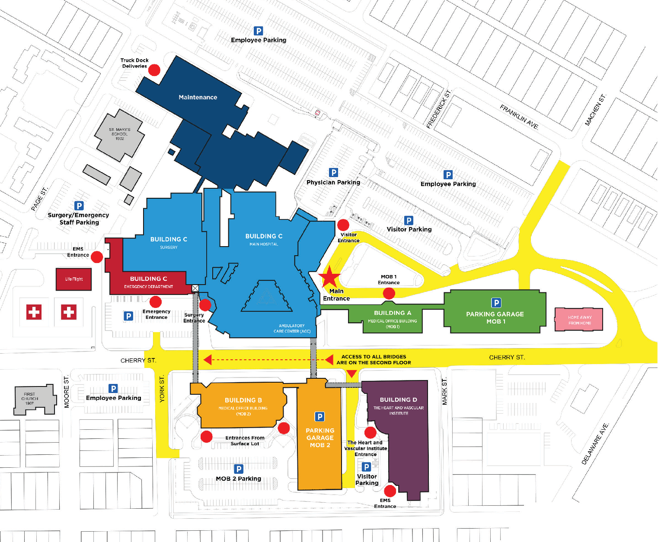

Campus Map

2213 Cherry St.

Toledo, OH 43608

**419-251-3232**

|  |
| --- |
| **BUILDING A**  Medical Office Building (MOB 1) |
| **BUILDING B**   * Nationwide Children’s   Hospital — Toledo (Outpatient)   * Outpatient Services * Medical Office Building (MOB 2) |
| **BUILDING C** |
| * Emergency Center |
| * St. Vincent Main Hospital   + Nationwide Children’s Hospital — Toledo (Inpatient)   + Ambulatory Care Center (ACC)   + Main Information Desk   + Occupational Health   + Outpatient Pharmacy, powered by Harness Health   + Surgery Center |
| **BUILDING D**  The Heart and Vascular Institute |
| **MAINTENANCE** |
| **HOME AWAY FROM HOME** |

**Parking**

NORTH

**Building Entrances**

 **Campus Driving Routes**

17470MERPRO (23.11)

Mercy Health-St. Vincent Medical Center

Medical Student Liaison 2222 Cherry Street, Suite 1300

Toledo, Ohio 43608

### Medical Student Personal Information Form

|  |  |  |  |
| --- | --- | --- | --- |
| Personal Information | | | |
| Last Name: First Name: Middle Initial: | | | |
| Street Address: | | | |
| City: | State: | | Zip Code: |
| Home Phone: | Cell Phone: | | |
| Email Address: | | | |
| Date of Birth: | | Place of Birth: | |
| Citizenship: | | Last 4 digits of SSN or Passport: | |
| Step 1 / COMLEX 1 Score: | | | |
| Emergency Contact | | | |
| Contact 1 | | Contact 2 | |
| Name: | | Name: | |
| Relationship: | | Relationship: | |
| Phone Number: | | Phone Number: | |
| Education | | | |
| Undergraduate Institution | | Medical School | |
| Name: | | Name: | |
| Location: | | Location: | |
| Graduation Date: | | Anticipated Graduation Date: | |

**What field are you interested in applying for your residency?**

I attest that I have read understand the Professional Image, Immunizations, and Infant Abduction Policies . I also state that I have read and understand the student handbook for this site

**_Signature Date**

**It is important that we always maintain current information on file. Should any of the above information change,** [**please notify Darcy B**](mailto:dbrowne@mercy.com)**rowne, Medical Student Liaison immediately at (419) 251-2895 or email** [**dbrowne@mercy.com**](mailto:dbrowne@mercy.com)

# Confidentiality and SecurityAgreement

Bon Secours Mercy Health (BSMH) has a legal and ethical responsibility to safeguard the privacy of all patients, residents, and clients and to protectthe confidentiality of theirpersonal health information. BSMH must alsoprotect the integrityandconfidentiality of organizational information andinformationsystemsthat may include, but are not limited to, fiscal, research, internal reporting, strategic planning, communications, andcomputer systems from anysource or in any formincluding, without limitation, paper, magnetic or optical media, conversations, electronic, and film. For thepurposeof this Agreement, all such information is referred to as “Sensitive Data.”

**I UNDERSTAND AND HEREBY AGREE THAT:**

1. During my employment/affiliation with BSMH, I understand that I may have access and exposure to Sensitive Data.
2. I will access and / or use Sensitive Data only as necessary to perform my job-related duties and in accordance with BSMH’s policies and procedures.
3. My User-ID and password are confidential, and in certain circumstances may be equivalent to my **LEGAL SIGNATURE,** and I will not disclosethem toanyone. Iunderstandthat Iamresponsibleandaccountableforallentriesmadeandallinformation accessed under my User-ID.
4. I will notcopy,release, sell, loan, alter, or destroy any Sensitive Data except as properly authorized by law or BSMH policy.
5. I will not discuss Sensitive Data so that it can be overheard by unauthorized persons. It is not acceptable to discuss information that can identify a patient in a public area even if the patient’s name is not used.
6. I will only access and / or use systems or devices I am authorized to access and will not demonstrate the operation or function of systems or devices to unauthorized individuals.
7. I have no expectation of privacy when using BSMHinformationsystems. BSMH has the right to log, access, review, and otherwise use information stored on or passing through its systems, including e-mail.
8. I will never connect to unauthorized networks through BSMH’s systems or devices.
9. I will practicesecure electronic communications by transmitting Sensitive Data in accordance with approved BSMH security standards.
10. I will practice good workstation security measures such as never leaving a terminal unattended while logged in to an application, locking up removable media when not in use, usingscreen savers with activated passwords appropriately, and positioning screens away from public view.
11. I will:
    1. Use only my assigned User-ID and password.
    2. Use only approved licensedsoftware.
    3. Use a device with virus protection software.
    4. Not attempt to learn or use another’s User-ID and password.
    5. Not store sensitive data that is not in accordance with BSMH policy and standards.
12. I will disclose Sensitive Data only to authorized individuals with a need to know that information in connection with the performance of their job function or professionalduties.
13. Unauthorized or improperuse of BSMH’sinformationsystems and / or Sensitive Data, is strictly prohibitedand maynot be covered by BSMH’s insurance or my personal professional malpractice insurance. **Any such violation may subject me to personal liability as well as sanctions for violation of state and federal law.**
14. I will notify my manager, BSMH Privacy Officer,IS Security, orotherappropriate Information Services personnelif my password has been seen, disclosed, or otherwise compromised.
15. Upontermination of my employment / affiliation / association with BSMH, I will immediatelyreturn or destroy, as appropriate, any Sensitive Data in mypossession.
16. Violation of this Agreement may result in disciplinary action, up to and including civil or criminal action, termination of employment / affiliation / association with BSMH, and suspensionand / or loss of medicalstaffprivileges in accordance with BSMH’spolicies.
17. My obligations underthis Agreement will continue after termination of employment / affiliation / association with BSMH.

**By signing this document, I acknowledge that I have read this Agreement, and I agree to comply with all the terms and conditions stated above.**

Signature Date

Printed Name

Non-BSMH Organization Name

REV 3/22

## Training Expectations

1. Sign into Epic with User ID and password
2. Student to complete eLearning modules:
   * Student to complete Inpatient modules if working in the inpatient setting
   * Student to complete ED modules if working in the ED
   * Student to complete both Inpatient and ED modules if completing a rotation in both settings
3. Sign Training Attestation
   * Student to complete attestation for both Inpatient and ED modules if working in both settings
4. If you experience any issue in the steps below, including login, please call the **Mercy Help Desk 1-833-691-4357**

## Step # 1 – Required eLearning

1. From a hospital computer, launch the Epic Icon to login.
2. Enter your credentials
   1. **Username**: Enter your Active Directory (AD) username
   2. **Password**: Enter your password
   3. This is case sensitive
   4. Login with the password provided by the student coordinator. If you did not receive a password, follow the prompts below for the generic password. If you experience any issue with your password, call into the Mercy Help Desk at **1-833-691-4357** for a password reset.
      * 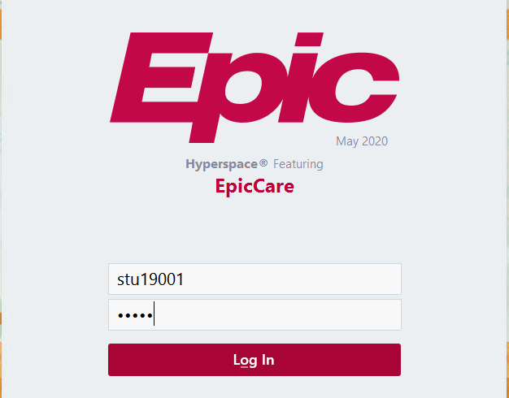Formula/Schema: Last 4 of Student ID/SSN split with a #, plus 'Temp@', plus lowercase first initial and lowercase last initial Example (Greg Nelsen): 12#34Temp@gn
      * 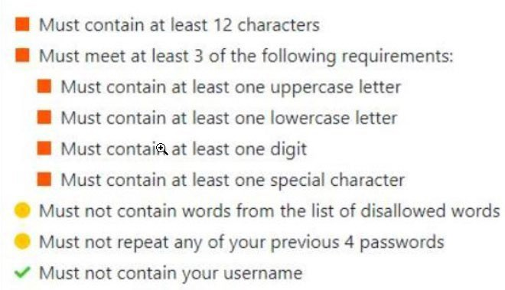New Password guidelines

#### Department:

**Inpatient:** Students working in an inpatient department will need to enter the site’s hospital acronym, followed by

**DR**, and the **specialty**. Click the **continue** button once you have entered the login department.

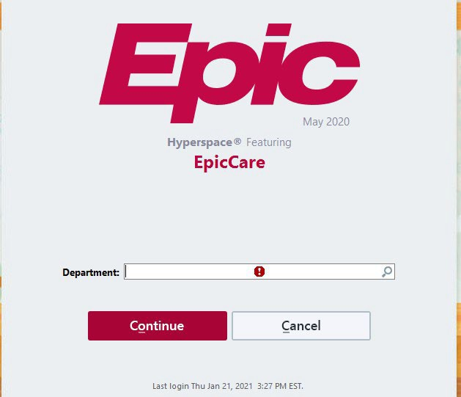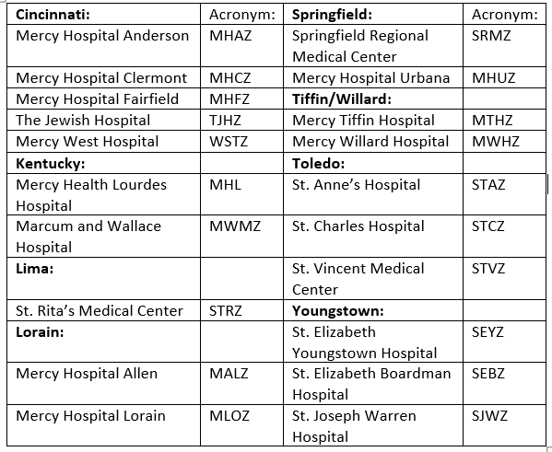**Example**: SEYZ DR Internal Medicine (not case sensitive)

**Emergency:** Students working in the emergency department will continue to use the hospitals acronym followed by

**emergency.** Click the **continue** button once you have entered the login department.

**Example:** SEYZ Emergency

NOTES:

* Login department drives specific tools needed for the assigned role.
* EPIC defaults to most recent department logged into.
* Use the magnifying glass to change departments using the above chart for site acronyms and following the DR SPECIALTY for Inpatient departments and Emergency (omit DR) for emergency departments

1. Once you have entered your department, you will be logged into Epic. To access the eLearning modules, click the **bar graph icon** in the top left hand corner of the screen under the Epic button. Select the **IP Provider Learning Home.**
2. 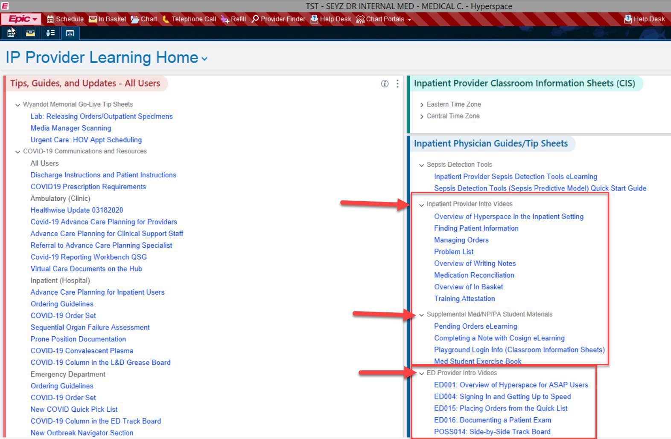The Provider Learning Home Dashboard will open, and the eLearning modules will be located on the right of the screen under the section titled Inpatinet Physician Guides/Tip Sheets.
3. Under the section **Inpatient Provider Intro Videos**, watch the required eLearnings:
   1. Overview of Hyperspace in the Inpatient Setting

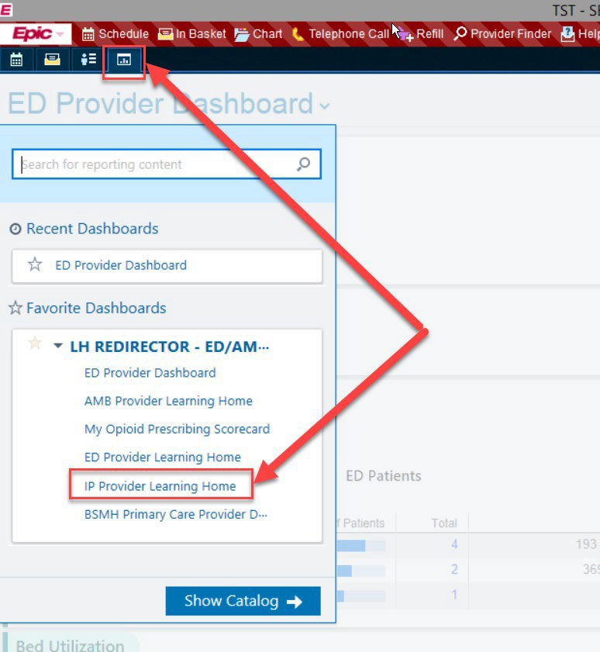

* 1. Finding Patient Information
  2. Managing Orders
  3. Problem List
  4. Overview of Writing Notes
  5. Medicaion Reconcillaiton
  6. Overview of In-Basket



1. Under the **Supplemental Med Student Materials** there are two additional required videos specific to your inpatient role to watch:
   1. Pending Order elearning
   2. Completing a note with cosign eLearning
2. Under the **ED Provider Intro Videos**, watch the required eLearnings:
   1. Overview of Hyperspace for ASAP Users d. Documenting a Patient Exam
   2. Signing In and Getting Up to Speed e. Side-by-Side Track Board
   3. Placing Orders from the Quick List

## Step #2 – Training Attestation

1. Once you have completed all required eLearning vidoes. Click on the **Training Attestation** hyperink to complete
2. Complete separate attestions for Inpatient and Emergency eLearnings

|  |  |
| --- | --- |
| **Guideline Name:** | Associate Immunization Program |
| **Department:** | Associate Health & Safety Services |
| **Functional Area:** | Associate Health & Safety Services |
| **Contributing Department** | Infection Prevention & Control, Pharmacy and Human Resources |
| **Approved by:** | Elia Stanko, Director Associate Health & Safety Services |
| **Effective Date:** | 4/21/2021 |
| **Version:** | 14 |
| **Guideline Status:** | Approved |
| **Manual:** | Associate Health Services |
| **Section:** | All markets |

#### Mission, Vision and Values

It is the goal of Bon Secours Mercy Health to ensure the organization’s mission, vision, and values are reflected in all BSMH system-wide policies, procedures, and guidelines.

#### Scope

All Bon Secours Mercy Health (BSMH) associates unless otherwise noted in collective bargaining unit agreements. It is the expectation that all non-BSMH associates, contractors, affiliates, volunteers, and students also adhere to these requirements.

#### Guideline Statement

It is the policy of BSMH for associates and prospective associates to participate in the Associate Immunization Program requirements to ensure the health and safety of all BSMH patients, residents and associates. Associate Health & Safety Services supports and maintains the health, wellbeing, and safety of its associates with vaccination guidelines that protect the healthcare needs of associates relevant to employment/service as required by regulatory agencies, BSMH policy and recommendations by the Centers for Disease Control and Prevention (CDC). It is the expectation that all non-BSMH associates, contractors, affiliates, volunteers, and students adhere to these requirements.

#### Department/Function Details

* 1. Immunizations will be administered as part of the pre-employment process and/or as indicated during employment. Immunizations will be given per CDC guidelines and BSMH policies to include proper education (i.e., Vaccine Information Sheets) and consent.
  2. Exemption to required vaccination when indicated:
     1. Associates who declining a required vaccine due to an exemption, Bon Secours Mercy Health may, at its sole discretion and in accordance with applicable law, policies, and procedures, choose to temporarily place you on an unpaid leave of absence or end employment due to the need to manage communicable diseases to provide safe, high-quality healthcare.
     2. If an associates or prospective associate indicates a medical contraindication and has been advised against having required vaccination(s) by their provider, documentation from the associate’s or prospective associate’s provider will be required when submitting a medical exemption request.
        1. Flu vaccination exemption requests are submitted through Workday.
        2. All other vaccination exemption requests are made directly with Associate Health.
        3. Temporary accommodations to delay receiving a vaccine due to a medical condition shall follow the medical exemption process utilizing both CDC guidelines and the interactive process.
     3. Associates or prospective associates with sincerely held religious beliefs that object to required vaccination(s) should initiate a vaccine exemption request declaring and affirming a sincerely held religious belief prohibiting vaccinations. An associate or prospective associate’s sincerely held religious beliefs objecting to vaccinations should remain consistent to maintain the exemption.
  3. Associates who have approved medical and/or a sincerely held religious belief exemptions from a vaccine are required to adhere to all recommended infection prevention guideline requirements.
  4. Associate Health & Safety Services manages vaccine tracking for all BSMH associates.
     1. BSMH Associate Health & Safety Services collects and aggregates vaccination information for associates, and as required, other categories of personnel to include but not limited to non- associates Staff, Vendors, Contractors, Students, and Volunteers.
     2. Data can be collected from a variety of sources, including but not limited to Workday, Associate Health & Safety Services vaccine administration records, associate vaccine card/record submission.
     3. The secure electronic tracking database is access controlled and contains information, to include, but not limited to: Name, secondary identifier, vaccine detail (date, dose, manufacturer, lot, dose in a series including boosters), titer detail (date, result), exemption detail (medical or sincerely held religious belief, date issued, specific vaccine exemption). This database will also track those that required a temporary vaccine delay and a reason for the delay.
  5. Associate Health & Safety Services offer vaccines required for healthcare workers free of charge to all BSMH associates and prospective associates.
  6. If associates or prospective associates within the scope of this policy are vaccinated through services outside of BSMH, proof of vaccination must be provided to Associate Health & Safety Services.
  7. Associates who decline the required vaccines waive their right to short term disability compensation benefits and paid leave should there be an exposure while at work.

The vaccines subject to this policy are as follows:

|  |  |
| --- | --- |
| **Disease/Vaccination** | **Procedure and Requirements** |
| Hepatitis B | * All prospective associates with potential for occupational exposure to blood and body fluids and without proof of prior vaccination are offered the Hepatitis B vaccine within 10 days of initial assignment to a job where there is occupational exposure, unless the worker has previously received the vaccine series, antibody testing has revealed that the worker is immune, or the vaccine is medically contraindicated. *(refer to Hepatitis B Immunization policy).* * Hepatitis B Surface Antibody will be drawn only when the associate has completed the vaccine within the past 1-2 months or at the time of a bloodborne pathogen exposure. * If the prospective associate elects not to receive the Hepatitis B vaccine, written   declination is obtained. |
| Measles, Mumps and Rubella | * Prospective associates without proof of 2 MMR vaccines will have titers drawn to determine immunity. * Prospective associates with proof of one MMR will receive a second MMR to   complete the series as recommended. |

|  |  |
| --- | --- |
|  | * If any titer is negative or equivocal then the prospective associate is required to receive MMR immunization as per CDC recommendations within four weeks of   hire. |
| Meningococcal | * Meningococcal vaccine is available for associates working in Microbiology with potential exposure to meningococcal bacteria. * Microbiologists who are routinely working to isolate of N. meningitidis should be   vaccinated with both MenACWY and MenB vaccines. The two vaccines may be given concomitantly but at different anatomic sites, if feasible. |
| Varicella | * Varicella titers will be drawn on all prospective associates without proof of vaccination, or proof of a positive titer. * If any titer is negative or equivocal, the prospective associate will receive Varicella vaccine as per CDC recommendations.   + If vaccine is declined for medical or religious reasons, counsel associate on post exposure work restrictions (refer to policy: *Guidance for Communicable Disease Management for Employees*).   + Prospective associates with a stated history of varicella vaccination unable to provide proof of immunization will be managed as the non- immune associate. * Varicella immunization requires two vaccines, four to six weeks apart. If a varicella like rash develops, the associate must be evaluated by the medical director and/or designee to determine work status. Associates developing a varicella rash following vaccination may not work with immunosuppressed patient populations. * Associates with proof of only one varicella vaccine at time of hire will receive the second varicella vaccine. * If any titer is negative or equivocal then the prospective associate is required to receive Varicella immunization as per CDC recommendations within four weeks of hire. |
| Tetanus, Diphtheria, and Pertussis | * Tdap is offered to all prospective associates. * Tdap is required for prospective associates hiring into Family Birthing Units (Labor & Deliver, Mother-Baby), Respiratory Therapy, Emergency Departments and Bone Marrow Transplant units. * If a tetanus booster is required and associate has already received Tdap, Td or   TT may be used. |
| Influenza | * Influenza vaccine is administered in the fall of each year. * Required BSMH associates must be immunized against influenza each year when seasonal influenza vaccine becomes available.   + Associates who exclusively work remotely with no onsite responsibilities will not be required but are strongly encouraged to become vaccinated. * If associates are vaccinated through services outside of BSMH, proof of vaccination must be provided through Workday. * Required associates must adhere to the Influenza program deadlines to avoid progressive discipline up to and including termination, as listed in this policy. |
| COVID-19 | * COVID-19 vaccination is recommended for everyone ages 6 months and older in the United States for the prevention of COVID-19. * CDC recommends that people stay [up to date](https://www.cdc.gov/coronavirus/2019-ncov/vaccines/stay-up-to-date.html) with COVID-19 vaccination. * All associates are required to adhere to all recommended infection prevention guideline requirements. * The current infection prevention and masking guidelines are based on CDC   recommendations and can be found on BSMH Central: [PPE](https://healthpartners.sharepoint.com/sites/Quality-Safety-and-Reliability/SitePages/COVID-19.aspx#personal-protective-equipment) |

|  |  |
| --- | --- |
|  | *Additional measures may be implemented as needed and current requirements can be referenced by contacting Associate Health & Safety Services.*   * All associates shall self-monitor for symptoms, stay home from work when   experiencing COVID related symptoms (unless crisis staffing plan is in effect). |

Vaccination Compliance:

BSMH will comply with all federal and state guidelines. New hire required vaccination must be completed within four weeks of hire to avoid a rescinded offer of employment. Associates non-compliant to vaccination requirements will be subject to progressive discipline, up to and including termination. Vaccine compliance is managed by Human Resources adhering to the following corrective action steps.

|  |  |
| --- | --- |
| **Level** | **Action** |
| 1 | Verbal warning. Interactive discussion and counseling with employee to examine potential alternatives or accommodation. |
| 2 | Written warning with one week to comply. |
| 3 | Final written warning with one week to comply. |
| 4 | Terminate. |

#### Definitions

None

#### Related Policies

Guidance for Communicable Disease Management Corrective Action

#### Regulatory Notices

Vaccine Compliance Data Tracking - Policy Addendum for non-associates

For the purposes of maintaining vaccine compliance information, the table listing below provides a summation of its location. Consolidated COVID compliance reports will be available through Workday.

|  |  |  |
| --- | --- | --- |
| Non-Associate Type | Platform Used for Compliance Capture | How Manager Acquires COVID Data |
| Volunteers | Extend (All, including high school or college shadow students, Project Search participants, "volunteens") | From volunteer |
| Students | Extend (Allied Health & Graduate Medical Education (GME) students) | From school or student |
| Castlebranch (Nursing students) | N/A (*Student inputs into Castlebranch)* |
| Agency Staff | Simplify VMS to Workday (All domestic agency, including travel nurses) *Nursing went live 10/2022, All*  *others live Q1 2023* | N/A (*Agency inputs into VMS)* |
| **Extend** (International agency nurses only) | From agency |
| Affiliate Providers | Verity (All) | N/A (*Managed through med staff)* |
| Vendors, Contractors & Service Providers | Extend (Facility mgt contractors, support service vendors and other third-party onsite service providers: *i.e., Food and Nutrition Services, Environmental Services other*  *clinical services)* | From worker |

|  |  |  |
| --- | --- | --- |
|  | Symplr (Vendor and manufacturer sales personnel, repair and maintenance technicians, equipment specialists, equipment installation, construction) | N/A (*Vendor rep inputs into Symplr)* |

#### Version Control

|  |  |  |  |  |  |
| --- | --- | --- | --- | --- | --- |
| **Version** | **Approved Date** | **Next**  **Review Date** | **Description** | **Supersedes, if applicable** | **Prepared By** |
| 1.0 | 4/21/2021  Original Date |  |  |  | Elia Stanko, Director Associate Health & Safety Services |
| 12.0 | 12/1/2024 | 7/26/2026 | Approved |  | Elia Stanko, Director Associate Health & Safety Services |

This policy/procedure/guideline is not intended to establish a standard of clinical or non-clinical care or practice. Rather, this policy/procedure/guideline creates a general tool to help guide decision-making with the understanding that different action(s) may be necessary in response to the totality of the circumstances presented.

Sites revised 01/21/2024 - Bon Secours Mercy Health adopts the above policy, procedure, policy & procedure, guideline, manual / reference guide / instructions, or principle / standard / guidance document for all Bon Secours Mercy Health entities including, but not limited to, facilities doing business as Mercy Health – St. Vincent Medical Center, St. Vincent – St. Charles Hospital, St. Vincent – St. Anne Hospital, Mercy Health – Perrysburg Medical Center, Mercy Health – Tiffin Hospital, Mercy Health – Willard Hospital, Mercy Health – Defiance Hospital, Mercy Health Allen Hospital LLC, Mercy Health - Lorain Hospital, Mercy Health St. Elizabeth Youngstown Hospital, Mercy Health St. Joseph Warren Hospital, Mercy Health - St. Elizabeth Boardman Hospital, Mercy Health - St. Rita’s Medical Center, Mercy Health – Springfield Regional Medical Center, Mercy Health - Urbana Hospital, Mercy Health - Anderson Hospital, Mercy Health - Clermont Hospital, Mercy Health – Fairfield Hospital, Mercy Health - West Hospital, The Jewish Hospital – Mercy Health, Mercy Health – Kings Mills Hospital, LLC, Mercy Health

- Lourdes Hospital LLC, Mercy Health – Marcum and Wallace Hospital, Chesapeake Hospital Corporation DBA Rappahannock General, Maryview Hospital, Bon Secours Richmond Community, Bon Secours Memorial Regional Medical Center, Bon Secours – St. Mary’s Hospital, Bon Secours St. Francis Health System, Bon Secours St. Francis Medical Center, Bon Secours Mary Immaculate Hospital, Bon Secours - Southside Medical Center, Bon Secours Mercy Health Franklin, LLC, and Southern Virginia Medical Center. This also may apply to Bon Secours Mercy Health Medical Group LLC and its medical group affiliates.

Notes:

The last review date is the last date it was reviewed whether there were revisions made or not. The last modified date is the last time a revision was made to the document.

The original date is the date that the policy went live for the very first time.

|  |  |  |
| --- | --- | --- |
| **Number: 01.01 CODE ADAM**  **INFANT/CHILD ABDUCTION** | **Page 1 of 2** | **Originated: 1/1/2022 Reviewed: 07/15/2024 Revised: 08/23/2024** |

**SUBJECT:** Code Adam Infant/Child Abduction

**PURPOSE:** Mercy Health St. Vincent (MSV) and Nationwide Children’s Hospital Toledo (NCHT) have a specifically designated written plan of emergency preparedness to enable the institution to respond appropriately and quickly in the event of a suspected and/or confirmed missing child when staff do not know location of patient.

**POLICY:** The purpose of this plan is to ensure prompt and immediate action in the event of missing person under the age of 18 or a possible abduction. It is imperative that all activity and information regarding a missing person be controlled to minimize chaos and maximize the possibility of returning the person to safe surroundings and to maintain control of the situation until law enforcement agencies arrive.

**PROCEDURE**

*Departments/Individuals:*

1. The Unit initiating the Code Adam shall notify the MSV Protective Services Department immediately at 419-251-4444 or extension 1-4444 and give facility name, last known time and unit/location of missing child. Ambulatory off-site locations should notify local law enforcement.
   1. Specific identifiers to be included in communication to protective services and called overhead: Gender, Race, height, weight, and any information that can help identify abducted or abductee such as facial birthmark.
2. NCHT staff and leased personnel shall inspect their patient rooms to verify all infants/children are with their parents/guardians.
   1. If an infant/child is in a room with parents/guardian, instruct them to keep the infant/child in the room and the door closed. Ask visitors to remain in patient room. Report to the charge nurse that all infants/children are accounted for.
3. The NCHT Nurse Manager or designee shall explain to all patients that there is a missing child and (if appropriate) reassure them that their child is safe and should remain with them.
4. When all infants/children are accounted for, inspection of the remaining (empty) patient rooms shall begin. Keep lights on and the door open to all empty rooms signifying to other staff members that the inspection is complete and to avoid duplication of efforts.
5. The unit initiating the Code Adam shall restrict all traffic in and out of the unit.
6. Someone from the patient care department shall remain with the family of the missing child until Pastoral Care arrives.
7. MSV and NCHT staff shall station themselves in hallways and near exits to view areas in which a child and/or abductor may pass. Staff are to call the MSV Protective Services dispatch at 419-251- 4444 or 1-4444 immediately with any information regarding the missing child and potential abductor.
   1. EXAMPLE: If a staff member sees a person with a child (potential abductor) the staff may follow the person and ask another staff to call MSV Public Safety dispatch or the staff may use a hall phone to notify MSV Protective Services. Do not to stop the potential abductor.

*MSV Protective Services Department:*

See the MHSVMC Code Adam Plan for more information. *Telecommunications Notifications:*

1. An announcement will come over the MSV Public Address System (specific to the location) to announce the “Code Adam” and will include facility and department (ex. “Last known location: St. Vincent Main Hospital 7C Charlie, MOB1 1st floor, or St. Charles Progressive Care Unit”) where the incident occurred utilizing the phonetic military alphabet (Alpha, Bravo, Charlie, Delta, Echo), if applicable, for which wing of the facility.
2. A notification will also come over the mass communications system to MHSVMC and NCHT staff. The NCHT administration will also activate the Risk Assessment Team (RAT) conference call to notify NCH main campus.
3. Telecommunication will announce “Code Adam All Clear” after being notified by the MSV Public Safety dispatcher on the Code Line.

*Ancillary Services (i.e., Maintenance, Environmental services, Lab):*

See MHSVMC Code Adam plan for more information

*Marketing/Communications:*

See MHSVMC Code Adam Plan for more information. *General Information:*

* 1. If Code Adam called for a current inpatient or outpatient infant/child, the charge personnel from the identifying location shall immediately notify lab to hold any specimens that may be used for patient identification.
  2. Do not talk to the press. Direct all questions to NCHT Marketing and Communications.
  3. Stay calm and alert. Watch for anyone leaving with bundles or bags. As a rule, discharges are done in a wheelchair and newborns are not hand carried unless accompanied by a staff member.
  4. NCHT employees on the MHSVMC campus who had any type of contact with the situation shall complete a hospital incident report in event reporting system. All reports are to be done immediately following the incident.
  5. Remember that any information, no matter how trivial it may seem, could be the missing piece to the puzzle that would reunite the child with its family.
  6. Consider opening incident command.

Drills:

A unit specific drill must be completed biannually, and the results will be shared with the Safety/Medical Executive (MEC) Committee

Approved: 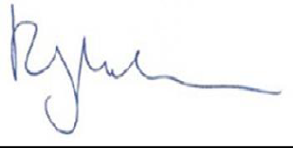

Rick Miller, President

Title: Patient Access Uniform Dress Code

Approved by: Christina Miele, System Director Revenue Management

Approval Date: 12/29/2023

Next Review Date: 12/29/2025

Effective Date: 12/29/2023

Policy Number: None

Supersedes: None

Originating Department: Patient Access Contributing Departments: None

Manual: Revenue Management

Section: Revenue Cycle – Front - Policies

Revision: 2

1. Scope

All Patient Access associates and authorized personnel.

1. Policy

Bon Secours Mercy Health sets professional standards in all areas of the organization. Appropriate appearance is an essential aspect of projecting respect for oneself and others, demonstrating human dignity and professionalism to our patients and visitors. Associates are expected to dress in acceptable attire and to show care in their appearance. Radical departures from conventional dress or personal grooming which draws attention away from the work associates are performing is not permitted, regardless of the nature of the job.

1. Procedure

During work hours, employees are expected to present themselves in a manner that promotes the safety of patients, residents, employees, and visitors, encourages congenial work habits, and protects personal and organizational property.

When duties routinely require an employee to work at a location other than his/her normal work area for an entire scheduled shift the dress code requirements applicable to that new location prevail.

On occasion, departments may elect to distinguish a particular manner of dress for departmental reasons/functions; any such departure from normal policy must be approved by the department director and the appropriate site leader, in advance.

The resolution of any question about the appropriateness of dress will be the responsibility of each employee’s immediate supervisor. Any employee who is unsure about dress code and/or personal appearance standards for their work area should confer with his/her immediate supervisor.

Human Resources (HR) may approve a limited exception to the standards set forth in this policy in any case, for good cause, if based on one or more of the following: cultural and/or religious beliefs, faith traditions or for medical necessity. An employee can apply for such an exception based on one or more of the stated grounds by submitting a request for accommodation to HR.

#### General Requirements:

Patient Access associates must abide by all guidelines listed in the corporate dress code and employee identification policy. The below specifics speak to uniform specific guidelines for site Patient Access team members.

#### Specifics:

Emergency Department

* 1. Tops must be the approved royal blue Bon Secours or Mercy Health tops
     1. Approved tops include scrub tops and scrub jackets.
     2. The underlay to the approved top must be white, grey, or black.
  2. Bottoms must be approved solid black dress pants or scrub bottoms.
  3. Shoes need to be appropriate to the work environment as well as within the market dress code policy.

#### All other Patient Access Areas:

1. Tops must be the selected royal blue Bon Secours or Mercy Health attire.
   1. Approved tops include V-neck sweater, sweater vest, cardigan sweater, approved registrar jacket, button up shirt.
   2. The underlay to the approved top must be white, grey, or black.
2. Bottoms are to be solid black dress pants or skirts.
   1. Skirt must be knee length and plain black.
   2. Prints or designs in skirts or pants are not permitted.
3. Shoes are business casual and within the dress code guidelines of the market policy.

#### Patient Access leadership (Supervisor and above):

1. Supervisor and above are to wear business casual attire as outlined in the BSMH Appearance and Attire policy.
   1. When staffing a scheduled shift, leaders must follow guidelines as outlined above depending on the department.

#### Corrective Action Process:

Any associate not dressed according to the policy stated above will be required to correct their attire immediately.

1. Upon discovery of a dress code infraction, a leader should speak with the associate, identify the infraction, and instruct the associate to clock out and correct the infraction.
2. Attendance points will be assigned based on the current attendance policy point system.
3. Corrective action issued per Attendance policy.
4. Definitions None
5. Attachments None
6. Related Policies/Procedures

None

1. References None

This policy/procedure/guideline does not establish a standard of clinical care or practice or standard of non-clinical practice to be followed in every case. The policy/procedure/guideline should guide actions with the understanding that departures may be required at times.

Sites revised 01/21/2024 - Bon Secours Mercy Health adopts the above policy, procedure, policy & procedure, guideline, manual / reference guide / instructions, or principle / standard / guidance document for all Bon Secours Mercy Health entities including, but not limited to, facilities doing business as Mercy Health – St. Vincent Medical Center, St. Vincent – St. Charles Hospital, St.

Vincent – St. Anne Hospital, Mercy Health – Perrysburg Medical Center, Mercy Health – Tiffin Hospital, Mercy Health – Willard Hospital, Mercy Health – Defiance Hospital, Mercy Health Allen Hospital LLC, Mercy Health - Lorain Hospital, Mercy Health St. Elizabeth Youngstown Hospital, Mercy Health St. Joseph Warren Hospital, Mercy Health - St. Elizabeth Boardman Hospital, Mercy Health - St. Rita’s Medical Center, Mercy Health – Springfield Regional Medical Center, Mercy Health - Urbana Hospital, Mercy Health - Anderson Hospital, Mercy Health - Clermont Hospital, Mercy Health – Fairfield Hospital, Mercy Health - West Hospital, The Jewish Hospital – Mercy Health, Mercy Health – Kings Mills Hospital, LLC, Mercy Health - Lourdes Hospital LLC, Mercy Health – Marcum and Wallace Hospital, Chesapeake Hospital Corporation DBA Rappahannock General, Maryview Hospital, Bon Secours Richmond Community, Bon Secours Memorial Regional Medical Center, Bon Secours – St. Mary’s Hospital, Bon Secours St. Francis Health System, Bon Secours St. Francis Medical Center, Bon Secours Mary Immaculate Hospital, Bon Secours - Southside Medical Center, Bon Secours Mercy Health Franklin, LLC, and Southern Virginia Medical Center.