2023-2024 Emergency Medicine Residents
CHIEF RESIDENTS
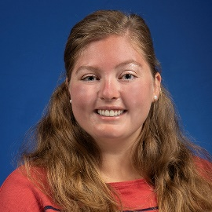 | Alexandra Brown, DO  Medical School: Michigan State University College of Osteopathic Medicine
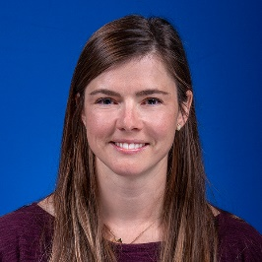 | Quinci Copeland, MD  Medical School: University of Toledo College of Medicine
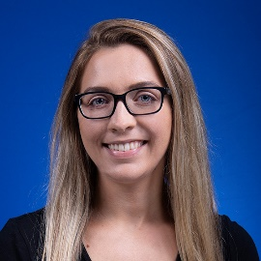 | Ashley Russell, MD  Medical School: Wright State University Boonshoft School of Medicine
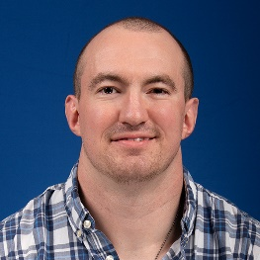 | Joseph Sharp, DO  Medical School: Philadelphia College of Osteopathic Medicine
PGY3 RESIDENTS
Alexandra Brown, DO
Medical School: Michigan State University College of Osteopathic Medicine
Quinci Copeland, MD
Medical School: University of Toledo College of Medicine
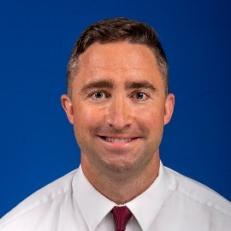 | Zachary Edwards, DO  Medical School: Campbell University School of Osteopathic Medicine
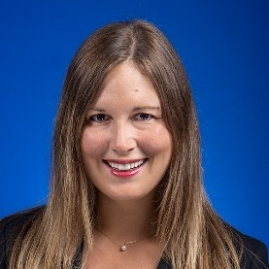 | Jennifer Ginsberg, MD  Medical School: St. George’s University School of Medicine
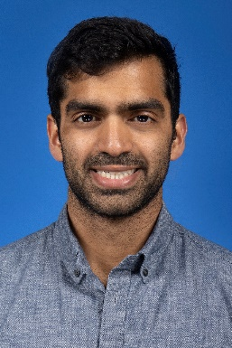 | Krishna Kidambi, DO  Medical School: William Carey University College of Osteopathic Medicine
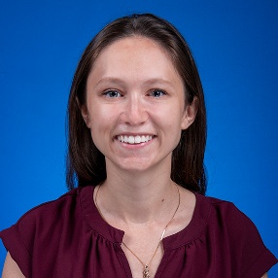 | Megan Ladd, DO  Medical School: Touro University College of Osteopathic Medicine
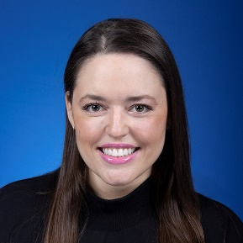 | Lauren Lessor, MD  Medical School: St. George’s University School of Medicine
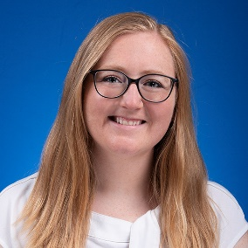 | Christian Posadny, MD  Medical School: University of Toledo College of Medicine
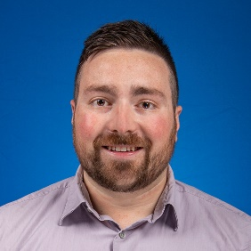 | Adam Ranellone, DO  Medical School: Kansas City University of Med & Biosciences, College of Osteopathic Medicine
Ashley Russell, MD
Medical School: Wright State University Boonshoft School of Medicine
Joseph Sharp, DO
Medical School: Philadelphia College of Osteopathic Medicine
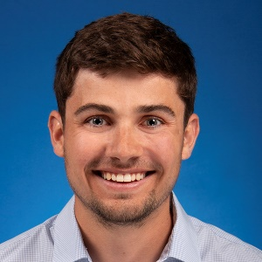 | Matthew Slack, DO  Medical School: West Virginia School of Osteopathic Medicine
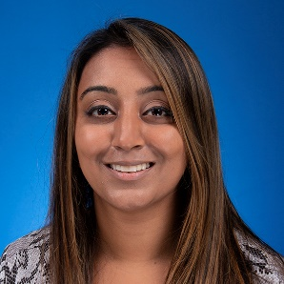 | Sriya Sureddi, MD  Medical School: University of Toledo College of Medicine
PGY2 RESIDENTS
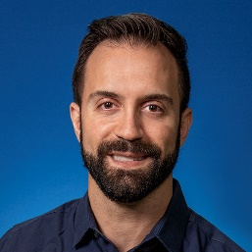 | Kemal Bahcheli, MD  Medical School: Medical University of the Americas (Nevis)
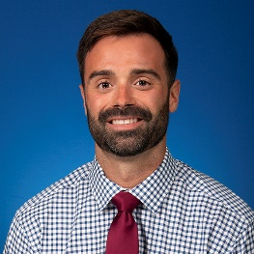 | Gregory Coots, DO  Medical School: Edward Via College of Osteopathic Medicine – Virginia Campus
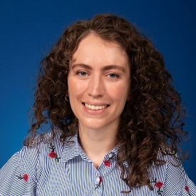 | Taryn Douglas, DO  Medical School: Kansas City University of Med & Biosciences, College of Osteopathic Medicine
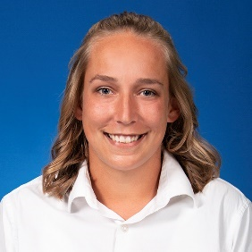 | Stacy Dybas, MD  Medical School: St. George’s University School of Medicine
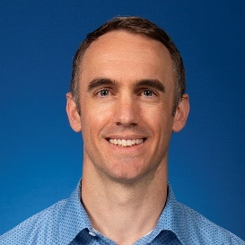 | Daniel Houser, MD  Medical School: Uniformed Services Uhs Fe Hebert School of Medicine
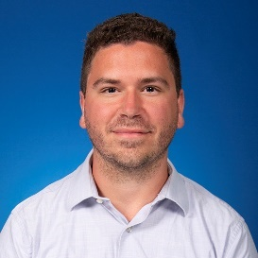 | George Iannantuono, DO  Medical School: Ohio University College of Osteopathic Medicine
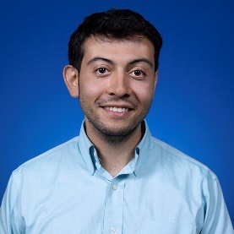 | Kareen Jarrah M.B.B.Ch.  Medical School: University College Cork School of Medicine
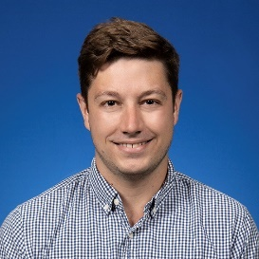 | Andrew Katko, MD  Medical School: University of Toledo College of Medicine
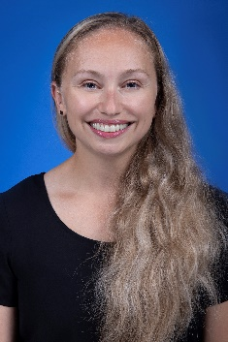 | Stephanie Krise, DO  Medical School: Ohio University Heritage College of Osteopathic Medicine
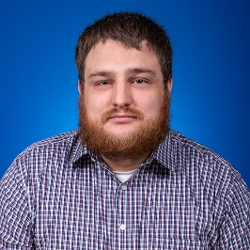 | Joseph Lawson, DO  Medical School: Lincoln Memorial University, DeBusk College of Osteopathic Medicine
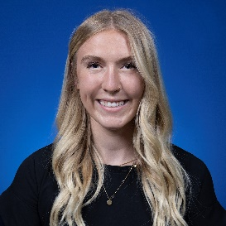 | Bailey Lervick, DO  Medical School: Idaho College of Osteopathic Medicine
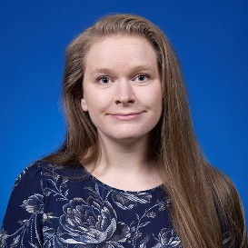 | Harmony Osborn, MD  Medical School: Michigan State University College of Human Medicine - Flint
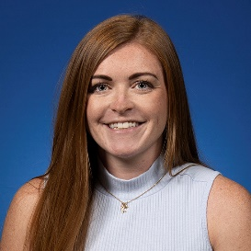 | Kennedy Rolfes, MD  Medical School: St. George’s University School of Medicine
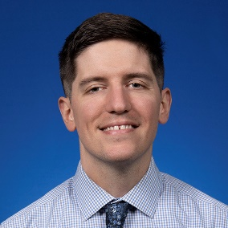 | Adam Starbuck DO  Medical School: Marian University College of Osteopathic Medicine
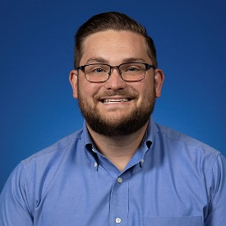 | Matthew Watz, MD  Medical School: Creighton University School of Medicine
PGY1 RESIDENTS
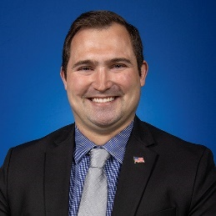 | Jonathan Desimone, DO  Medical School: Alabama College of Osteopathic Medicine
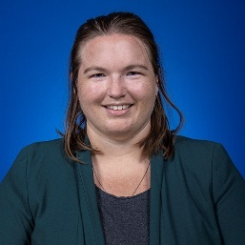 | Jessica Fisher, DO  Medical School: Lincoln Memorial University, DeBusk College of Osteopathic Medicine
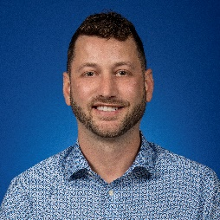 | Brandon Gosch, MD  Medical School: St. George’s University School of Medicine
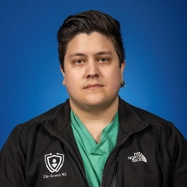 | Clinton Hartsock, MD  Medical School: Saba University School of Medicine
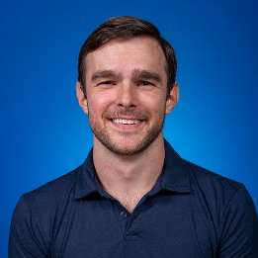 | W. Parker Howard, MD  Medical School: St. George’s University School of Medicine
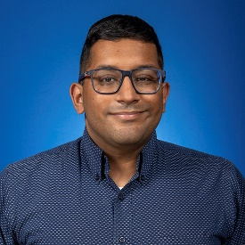 | Karthik Mohanarangan, MD  Medical School: University of Toledo College of Medicine
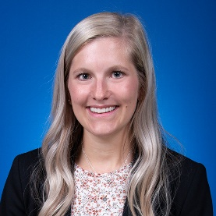 | Megan Ostlie, MD  Medical School: St. George’s University School of Medicine
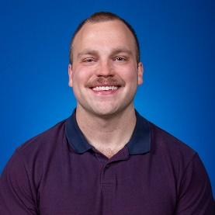 | Gilbert Phillips, DO  Medical School: Ohio University Heritage College of Osteopathic Medicine
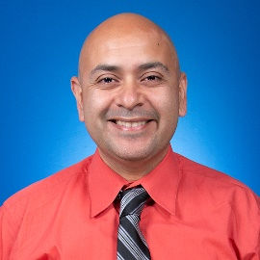 | Sergio Pina, MD  Medical School: Saba University School of Medicine
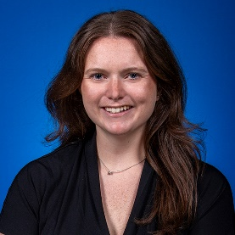 | Julie Ramon, MD  Medical School: Central Michigan College of Medicine
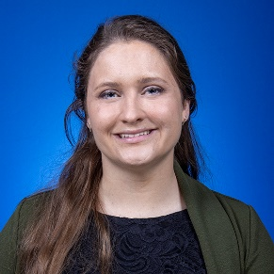 | Ariana Schuelke, DO  Medical School: Rocky Vista University College of Osteopathic Medicine
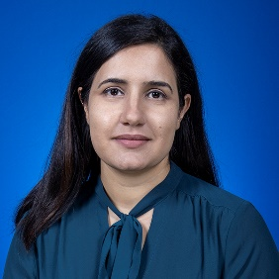 | Niloufar Siadati-Fini, MD  Medical School: Avalon University School of Medicine
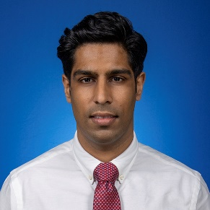 | Anmol Singh, MBBS  Medical School: Government Medical College Chandigarh
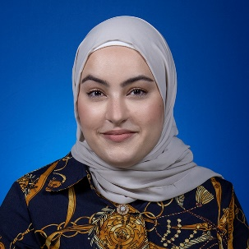 | Hebah Soudan, MBBS  Medical School: University of Sharjah College of Medicine

