2023-2024 Orthopedic Surgery Residents
CHIEF RESIDENTS
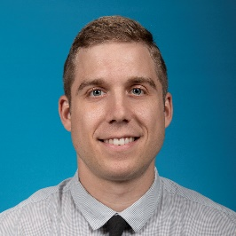 | Ryan Falbo, DO  Medical School: West Virginia School of Osteopathic Medicine
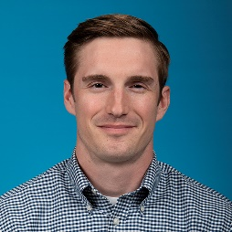 | Zachary Fulton, DO  Medical School: Kansas City University of Med & Biosc's, Col of Osteo Med
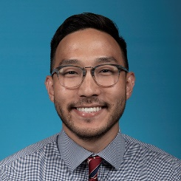 | Jae Min Yim, DO  Medical School: Ohio University Heritage College of Osteopathic Medicine
PGY4 RESIDENTS
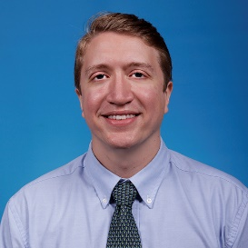 | Fortunato Padua, MD  Medical School: Tulane University School of Medicine
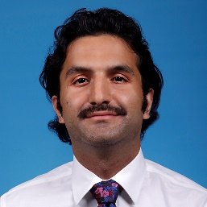 | Roman Rahmani, DO  Medical School:  University of New England, Col of Osteopathic Medicine
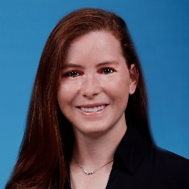 | Elizabeth Simmons, DO  Medical School: University of Pikeville, Kentucky Col of Osteopathic Med
PGY3 RESIDENTS
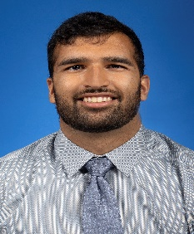 | Hassan Choudhry, DO  Medical School: Touro University Col of Osteopathic Medicine, New York
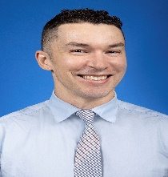 | Liam Ortega, DO  Medical School: Edward Via Col of Osteo Medicine-Carolinas Campus
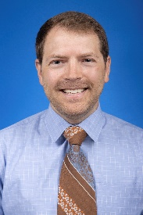 | Sean Porter, DO  Medical School: Lincoln Mem University, Debusk Col of Osteopathic Med
PGY2 RESIDENTS
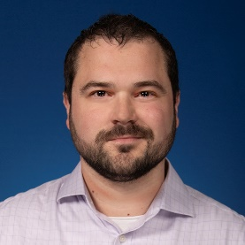 | Anthony Forrest, DO  Medical School:  Marian University College of Osteopathic Medicine
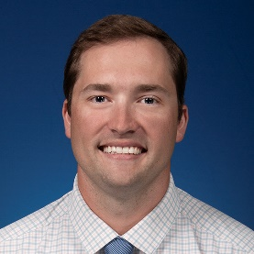 | John Hiatt, MD  Medical School: St. George's University School of Medicine
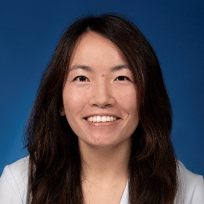 | Amy Singleton, DO  Medical School: Arizona College of Osteopathic Medicine
PGY1 RESIDENTS
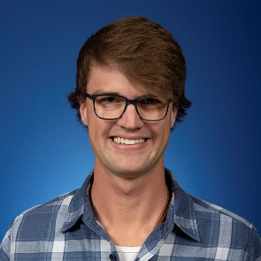 | Hunter Ostlie, MD  Medical School:  St. George's University School of Medicine
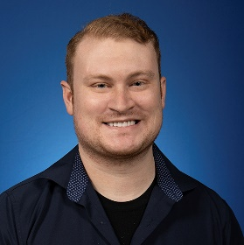 | Brandon Reiman, DO  Medical School:  Des Moines University, Col of Osteopathic Med & Surgery
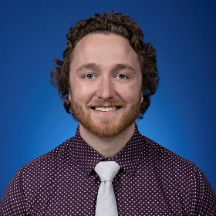 | James Richman, DO  Medical School: Lincoln Mem University, Debusk Col of Osteopathic Med

