2023-2024 (Insert Program) Residents
PGY5 / CHIEF RESIDENTS
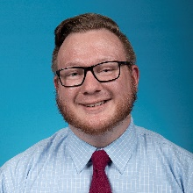 | James Ellis, DO  Medical School: University of Pikeville Kentucky College of Osteopathic Medicine
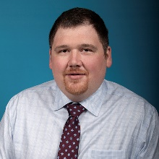 | Zachary Patterson, DO  Medical School: Touro University College of Osteopathic Medicine
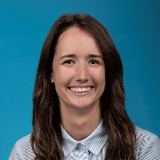 | Alyssa Ritchie, DO  Medical School: Ohio University Heritage College of Osteopathic Medicine
PGY4 RESIDENTS
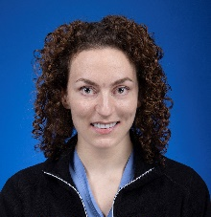 | Holly Calderon, DO  Medical School: College of Osteopathic Medicine of the Pacific
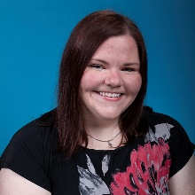 | Megan Crotty, DO  Medical School: Lake Erie College of Osteopathic Medicine
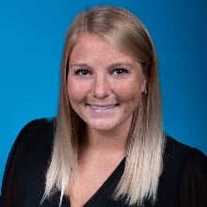 | Kylie Dickman, MD  Medical School: St. George’s University School of Medicine
PGY3 RESIDENTS
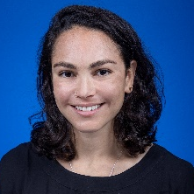 | Sarah Blau, DO  Medical School: Pacific Northwest University of Health Sciences College of Osteopathic Medicine
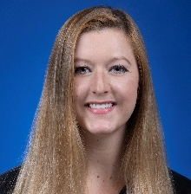 | Hayley Flynn, DO  Medical School: Ohio University Heritage College of Osteopathic Medicine
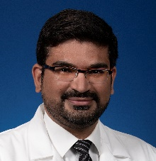 | Kartikeya Sharma, MD  Medical School: Maulana Azad Medical College
PGY2 RESIDENTS
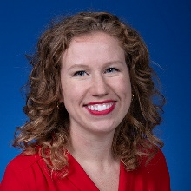 | Sarah Gaston, DO  Medical School: Ohio University Heritage College of Osteopathic Medicine
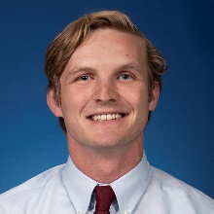 | Austin Gould, DO  Medical School: Edward Via College of Osteopathic Medicine - Alabama Campus
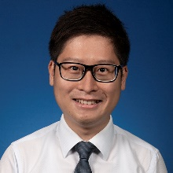 | Ka Hin Wong, DO  Medical School: Kansas City University of Medicine and Biosciences College of Osteopathic Medicine
PGY1 RESIDENTS
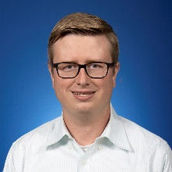 | Cody Buffkin, DO  Medical School: Edward Via College of Osteopathic Medicine - Carolinas Campus
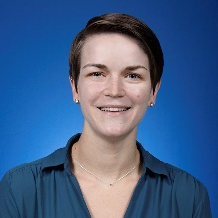 | Natalie Fallows, DO  Medical School: Edward Via College of Osteopathic Medicine - Alabama Campus
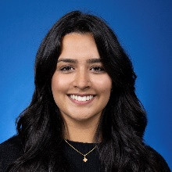 | Shruti Simlot, DO  Medical School: Kansas City University of Medicine and Biosciences College of Osteopathic Medicine

