2023-2024 Internal Medicine Residents
CHIEF RESIDENTS
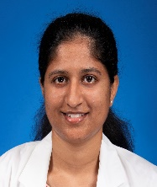 | Nagabindhu Sri Aravapalli  P.S.I. Medical College  M.B., B.S.
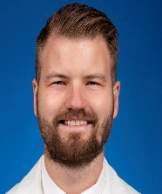 | Kyle Schroeder  St George's University  M.D.
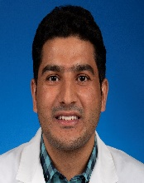 | Sadiq Ullah  Khyber Medical College  M.B., B.S.
PGY3 RESIDENTS
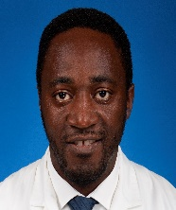 | Daniel Aloho Bekong  Université de Yaoundé I Faculté de Médecine et des Sciences Biomédicales  M.D.
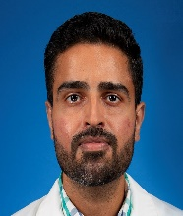 | Prabhsharn Grewal  Dayanand Medical College  M.B., B.S.
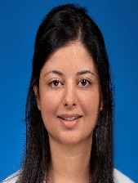 | Preetraj Kaur  Gian Sagar Medical College  M.B., B.S.
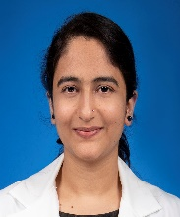 | Sawleha Arshi Khan  Mahatma Gandhi Mission's Medical College Aurangabad  M.B., B.S.
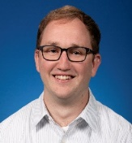 | Michael Moses D.O.  Lake Erie College of Osteopathic Medicine  D.O.
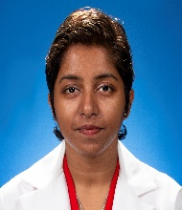 | Pragya Papaganti  Siddhartha Medical College  M.B., B.S.
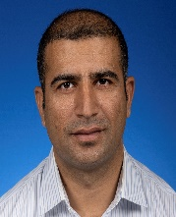 | Bakht Rahman  Khyber Medical College  M.B., B.S.
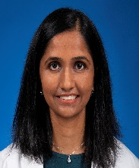 | Krishna Thakore  St George's. University  M.D.
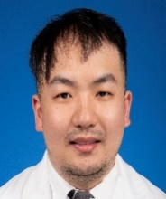 | Jieshen Wu  University of Toledo College of Medicine and Life Sciences  M.D.
PGY2 RESIDENTS
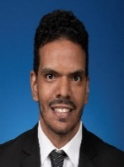 | Amr Alemairy  University of Khartoum Faculty of Medicine  M.B., B.S.
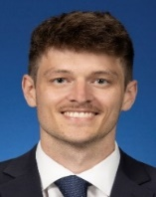 | Nicklaus Carrothers  Ross University School of Medicine  M.D.
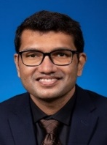 | Shudipan Chakraborty  Dhaka Medical College  M.B., B.S.
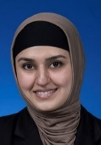 | Sidra Danish  Liaquat University of Medical & Health Sciences  M.B., B.S.
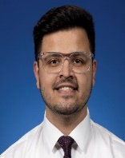 | Vallabh Dogra  Government Medical College Jammu  M.B., B.S.
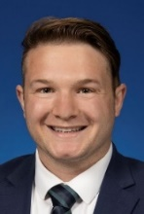 | Joseph Elder  St. George's University  M.D.
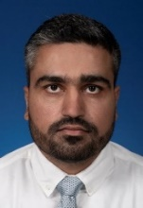 | Harsharn Grewal M.D.  Adesh Institute of Medical Sciences & Research  M.B., B.S.
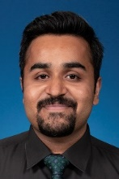 | Daniyal Ishtiaq  Rawalpindi Medical College  M.B., B.S.
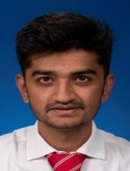 | Swapnil Lunagaria  Government Medical College Surat  M.B., B.S.
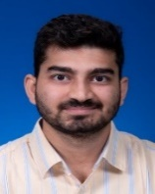 | Vineeth Potluri  Alluri Sitaram Raju Academy of Medical Sciences  M.B., B.S.
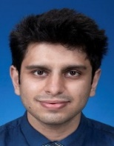 | Abhimanyu Rakesh  Sri Guru Ram Das Institute of Medical Sciences & Research  M.B., B.S.
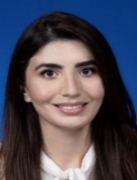 | Ayesha Tahir  Jinnah Medical College  M.B., B.S.
PGY1 RESIDENTS
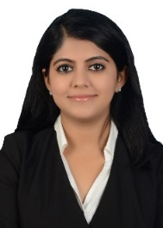 | Himani Badyal  Government Medical College Jammu  M.B., B.S.
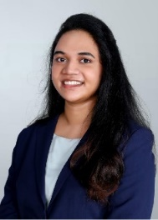 | Pranathi Bandarupalli  Alluri Sitaram Raju Academy of Medical Sciences  M.B., B.S.
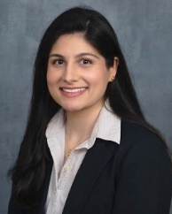 | Sanam Farooq  Spartan Health Sciences University  M.D.
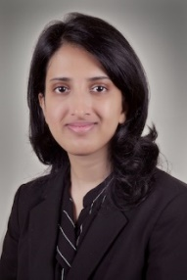 | Mansi Jain  Vardhman Mahavir Medical College & Safdarjung Hospital  M.B., B.S.
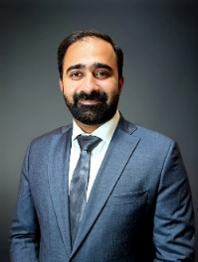 | Taimoor Jamil  King Edward Medical College  M.B., B.S.
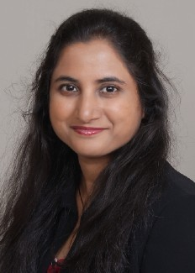 | Vishnu Priya Katragadda  MNR Medical College  M.B., B.S.
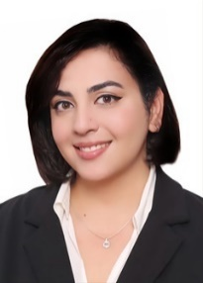 | Purnoor Kaur  Sri Guru Ram Das Institute of Medical Services & Research  M.B., B.S.
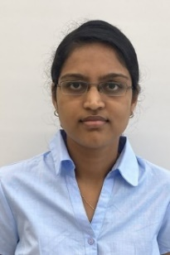 | Manogna Pendyala  Sri Devaraj Urs Medical College  M.B., B.S.
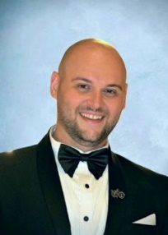 | Tarek Raad  University of Damacus  M. D.
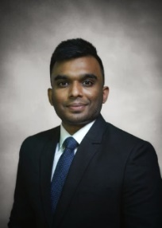 | Dhayananth Rattaipalivalasu Saravanan  PSG Institute of Medical Sciences and Research  M.B., B.S.
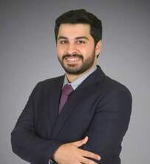 | Fahad Shaikh  Dow Medical College  M.B., B.S.
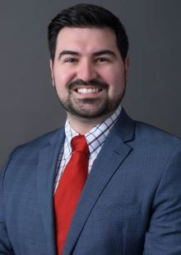 | Nicholas Zerilli  St. George’s University  M.D.

