2023-2024 (Family Medicine- Gandy) Residents
CHIEF RESIDENTS
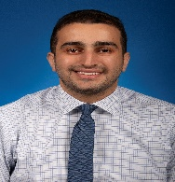 | Mutasem Abuhalaweh, MD – Administrative Chief  Medical School: Misr Univ for Science And Technology Col Of Med
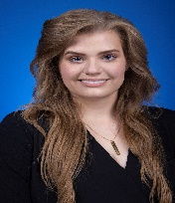 | Stacey Heindl, MD – Academic Chief  Medical School: Avalon University School of Medicine
PGY3 RESIDENTS
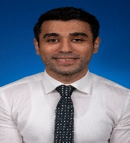 | Ahmed Durrani, MD  Medical School: Shaikh Khalifa Bin Zayed Al-Nahyan Medical & Dental College
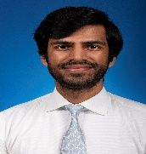 | Ahmad Javed, MD  Medical School: Alfaisal University College of Medicine
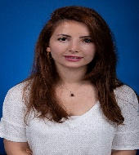 | Yasameen Kerakhan, MD  Medical School: University of Baghdad College of Medicine
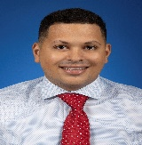 | Meina Missak, MD  Medical School: St. George's University School of Medicine
PGY2 RESIDENTS
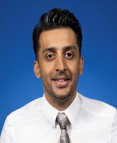 | Ozair Ali, MD  Medical School: Dow International Medical College (DIMC)
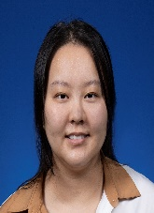 | Hyun-Ryung Choi, MD  Medical School: Saint James School of Medicine Anguilla
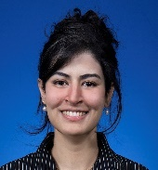 | Quratulain Hayder, DO  Medical School: Kansas City University of Med & Biosc's, Col of Osteo Med , Col of Osteo Med
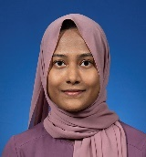 | Misbah Hassan, MD  Medical School: Fatima Jinnah Medical College for Women
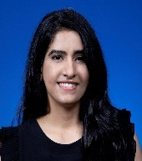 | Zeba Khavarian, MD  Medical School: Saba University School of Medicine
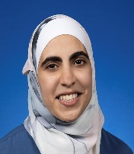 | Farah Sharieh, MD  Medical School: University of Jordan Faculty of Medicine
PGY1 RESIDENTS
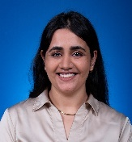 | Hafsa Fatima, MD  Medical School: Dow International Medical College (DIMC)
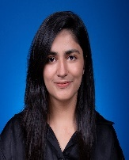 | Farah Khan, MD  Medical School: Nishtar Medical College & Hospital
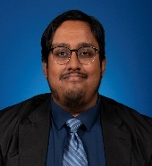 | Mashrur Moyeed, MD  Medical School: Ross University School of Med
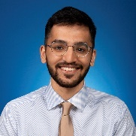 | Omar Neamatullah, MD  Medical School: Alfaisal University College of Medicine
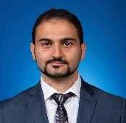 | Tarif Shaaban, MD  Medical School: Batterjee Medical College for Sciences and Technology
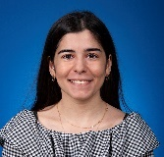 | Maya Zeini, MD  Medical School: Jordan Univ of Science and Technology Fac of Med

