2023-2024 Fellowship in Cardiovascular Disease Fellows
CHIEF FELLOW
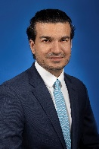 | Muhammad Shayan Khan, MD  Medical School: Khyber Medical College
PGY5 FELLOWS
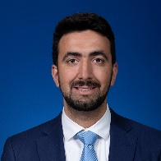 | Moaaz Baghal, MD  Medical School: Misr University for Science and Technology College of Medicine
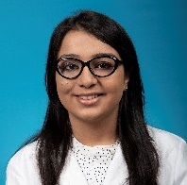 | Kritika Luthra, MD  Medical School: Kasturba Medical College Mangalore
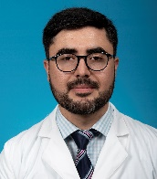 | Fnu Salman, MD  Medical School: Kabir Medical College
PGY4 FELLOWS
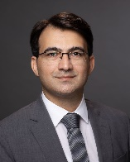 | Abdul Baqi, MD  Medical School: KMU Institute of Medical Sciences
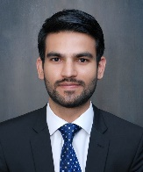 | Ghulam Mujtaba Ghumman, MD  Medical School: Services Institute of Medical Sciences

